Software Specifications and Tools
Final Report Part I
for
E-Lib
Version 1.1 approved
Prepared by Ionuț – Dragoș Neremzoiu
ACE UCV
17.01.2022
Table of Contents
Table of Contents ii
Revision History ii
1. Introduction 1
1.1 Purpose 1
1.2 Intended Audience 1
1.3 Product Scope 1
1.4 References 1
2. Overall Description 2
2.1 Product Perspective 2
2.2 Product Functions 2
2.3 Assumptions and Dependencies 2
3. Software Tools 2
3.1 Eclipse 3
3.2 Spring Tool Suite 4 3
3.3 Spring Framework 3
3.3.1 Spring Boot 3
3.3.2 Spring Security………………………………………………………………………………4
3.3.3 Spring Data JPA……………………………………………………………………………..5
3.4 Hibernate 5
3.5 MySQL and MySQL Workbench…………………...……………………………………………5
3.6 Apache Maven…………………………………………………………………………………….6
4. Initial System Arhitecture 7

Revision History
Name | Date | Reason For Changes | Version

Introduction

Purpose
This document is meant to serve as an introduction to the main specifications and tools used for E-Library software application. In this document the reader should be able to have a general idea on what kind of specifications the app will have and what kind of tools will be used in order to develop the app, after having an in-depth analysis on the content of the document.

Intended Audience
The application will target 3 types of users: the customer, the employee, and the administrator. Thus, when logging in, the application will be able to redirect the users based on their role and they will be provided access to content limited to what their authorization grants them.

Product Scope
E-Lib is a library management software product, which is meant to simplify real life library services, such as:

- Searching for a book an user is interested in borrowing.
- Managing the books in the library and the list of records of people who are currently borrowing a certain book in a more efficient way.
- Processing the reservations as an employee.

Such simplifications allow customers, employees, and administrators to interact remote and keep them updated about library-related notifications.

References
http://maven.apache.org/guides/
https://dev.mysql.com/doc/
https://hibernate.org
https://spring.io
https://spring.io/projects/spring-boot
https://spring.io/projects/spring-security
https://spring.io/projects/spring-data-jpa
https://www.baeldung.com/spring-security-registration-password-encoding-bcrypt
https://www.baeldung.com/spring-boot-security-autoconfiguration
https://en.wikipedia.org/wiki/Apache_Maven
https://mvnrepository.com
https://maven.apache.org
https://www.geeksforgeeks.org/difference-between-spring-and-spring-boot/
srs template iee

Overall Description

Product Perspective
The context for the creation of this application is the need for a more efficient and less time-consuming way of providing quality library services mentioned above in 1.1 for all three types of users, which will benefit from using this kind of application. Moreover, considering the COVID – 19 pandemic, such digital platform will reduce human contact, when it comes to the need for borrowing a book.

Product Functions
Customer:

- Make reservation for a book or multiple books.
- Extend reservation for up to 3 weeks without being fined.
- Search and check for available books.
- Check remaining time of reservations.

Employee:

- Confirm reservations
- Cancel reservations
- Search and check for available books

Administrator:

- Disable and enable accounts
- Update users’ role
- Manage or keep track of the books (such as inserting a new book, editing information about the book, or deleting the record of a certain book)

Assumptions and Dependencies
Since Apache Maven will be used as a build automation tool, certain dependencies on external modules, components, and other required plug-ins will be configured in order to simplify the process of software development. Some components can be found and retrieved from Maven Repository and configured in a pom.xml file and others are configured in a Spring file usually called application.properties, where usually details such as database access credentials are configured.

Software Tools

Eclipse

Eclipse is an IDE used in computer programming. It contains a workspace and an extensible plug-in system for customizing the environment. Since its primary use is for Java applications, it is mostly used for developing mobile, desktop GUI, web-based, enterprise, scientific, business, distributed and cloud-based applications.

Spring Tool Suite 4
Spring Tool Suite 4 is the next generation of Spring tooling for your favorite coding environment. Largely rebuilt from scratch, it provides world-class support for developing Spring-based enterprise applications, whether you prefer Eclipse, Visual Studio or Theia IDE.
In this particular case, it will provide support for Eclipse IDE.

Spring Framework

Spring Framework is an open-source application framework and inversion of control container for the Java platform. The framework’s core features can be used by any Java application, but there are extensions for building web applications on top of the Java EE (Enterprise Edition) platform. Although the framework does not impose any specific programming model, it has become popular in the Java community as an addition to the Enterprise JavaBeans (EJB) model.

The Spring framework can be considered a collection of sub-frameworks, also called layers, such as Spring AOP, Spring ORM (Object-Relational Mapping), Spring Web Flow, and Spring Web MVC. You can use any of these modules separately while constructing a Web application, as well as together to provide better functionalities in a Web application.

Spring Boot

Spring Boot is built on top of the conventional Spring Framework. So, it provides all the features of Spring and is yet easier to use than Spring. Spring Boot is a microservice-based framework, making a production-ready application in very less time. In Spring Boot everything is auto-configured. We just need to user proper configuration for utilizing a particular functionality. Spring Boot is very useful if we want to develop REST API.

Difference between Spring and Spring Boot:

Spring | Spring Boot
Spring is an open-source lightweight framework widely used to develop enterprise applications. | Spring Boot is built on top of the conventional Spring Framework, widely used to develop REST APIs.
The most important feature of the Spring Framework is dependency injection. | The most important feature of the Spring Boot is Autoconfiguration.
It helps to create a loosely coupled application. | It helps to create a stand-alone application.
To run the Spring application, we need to set the server explicitly. | Spring Boot provides embedded servers such as Tomcat, Jetty etc.
To run the Spring application, a deployment descriptor is required. | There is no requirement for a deployment descriptor.
To create a Spring application, the developers write a lot of code. | It reduces the lines of code need to write a Spring-based application.
It doesn’t provide support for the in-memory database. | It provides support for the in-memory database such as H2.

Spring Security

Spring Security is a powerful and highly customizable authentication and access-control framework. It is the de-facto standard for securing Spring-based applications.

Spring Security is a framework that focuses on providing both authentication and authorization to Java applications. Like all Spring projects, the real power of Spring Security is found in how easily it can be extended to meet custom requirements.

Features

- Comprehensive and extensible support for both Authentication and Authorization
- Protection against session fixation, clickjacking, cross site request forgery, etc.
- Servlet API integration
- Optional integration with Spring Web MVC.
- Java Configuration support.
- Much more…

Spring Security framework supports wide range of authentication models. These models either provided by third parties or framework itself. Spring Security supports integration with all of these technologies:

- HTTP BASIC authentication headers
- HTTP Digest authentication headers
- HTTP X.509 client certificate exchange
- LDAP (Lightweight Directory Access Protocol)
- Form-based authentication
- OpenID authentication
- Automatic remember-me authentication
- Kerberos
- JOSSO (Java Open Source Single Sign-On)
- AppFuse
- AndroMDA
- Mule ESB
- DWR(Direct Web Request)

Spring Data JPA

Spring Data JPA, part of the larger Spring Data family, makes it easy to easily implement JPA based repositories. This module deals with enhanced support for JPA based data access layers. It makes it easier to build Spring-powered applications that use data access technologies.

Implementing a data access layer of an application has been cumbersome for quite a while. Too much boilerplate code has to be written to execute simple queries as well as perform pagination, and auditing. Spring Data JPA aims to significantly improve the implementation of data access layers by reducing the effort to the amount that’s actually needed. As a developer you write your repository interfaces, including custom finder methods, and Spring will provide the implementation automatically.

Features:

- Sophisticated support to build repositories based on Spring and JPA
- Support for Querydsl predicates and thus type-safe JPA queries
- Transparent auditing of domain class
- Pagination support, dynamic query execution, ability to integrate custom data access code
- Validation of @Query annotated queries at bootstrap time
- Support for XML based entity mapping
- JavaConfig based repository configuration by introducing @EnableJpaRepositories

Hibernate

Hibernate ORM (or simply Hibernate) is an object-relational mapping tool for the Java programming language. It provides a framework for mapping an object-oriented domain model to a relational database. Hibernate handles object-relational impedance mismatch problems by replacing direct, persistent database accesses with high-level object handling functions. Hibernate's primary feature is mapping from Java classes to database tables, and mapping from Java data types to SQL data types. Hibernate also provides data query and retrieval facilities. It generates SQL calls and relieves the developer from the manual handling and object conversion of the result.

MySQL and MySQL Workbench

MySQL is a popular open-source relational database management system (RDBMS).

MySQL Workbench is the integrated environment for MySQL. It enables users to graphically administer MySQL databases and visually design database structures. It is available in two editions, the regular free and open-source Community Edition which may be downloaded from the MySQL website, and the proprietary Standard Edition which extends and improves the feature set of the Community Edition. In this particular case, I will use the Community Edition.

Apache Maven
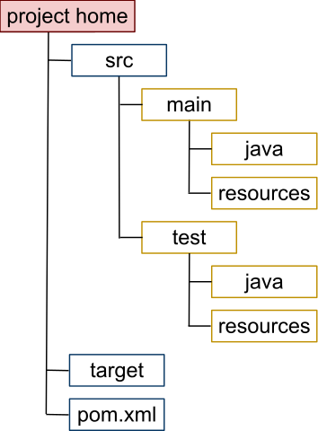
Maven is a build automation tool used primarily for Java projects. It addresses two aspects of building software: how software is built and its dependencies. An XML file describes the software project being built, its dependencies on other external modules and components, the build order, directories, and required plug-ins. It comes with pre-defined targets for performing certain well-defined tasks such as compilation of code and its packaging. Maven dynamically downloads Java libraries and Maven plug-ins from one or more repositories such as the Maven Repository: Central and stores them in a local cache. This local cache of downloaded artifacts can also be updated with artifacts created by local projects. Public repositories can also be updated.

A directory structure for a Java project auto-generated by Maven

Security Specifications and Communications Interfaces

Security Specifications
Security-wise, BCrypt, an encoding mechanism supported by Spring Security, will be used, since most of other encoding mechanisms, such as MD5PasswordEncoder (Message Digest) and ShaPasswordEncoder (Secure Hash Algorithm) use weaker algorithms and are now deprecated.

Communication Interfaces

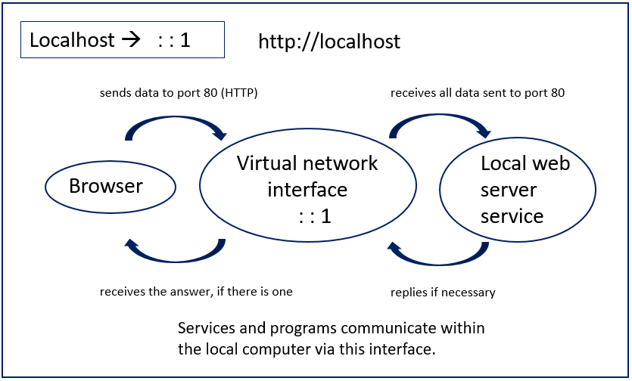
Developers use the local host to test web applications and programs and for local development. During development, it is important to find out whether the application works as developed once it has internet access, because releasing a product without testing doesn’t make sense. So, loopback is used by developers to test it. Developers can thus simulate a connection while also avoiding network errors. The connection just stays completely inside their own system.

Initial System architecture

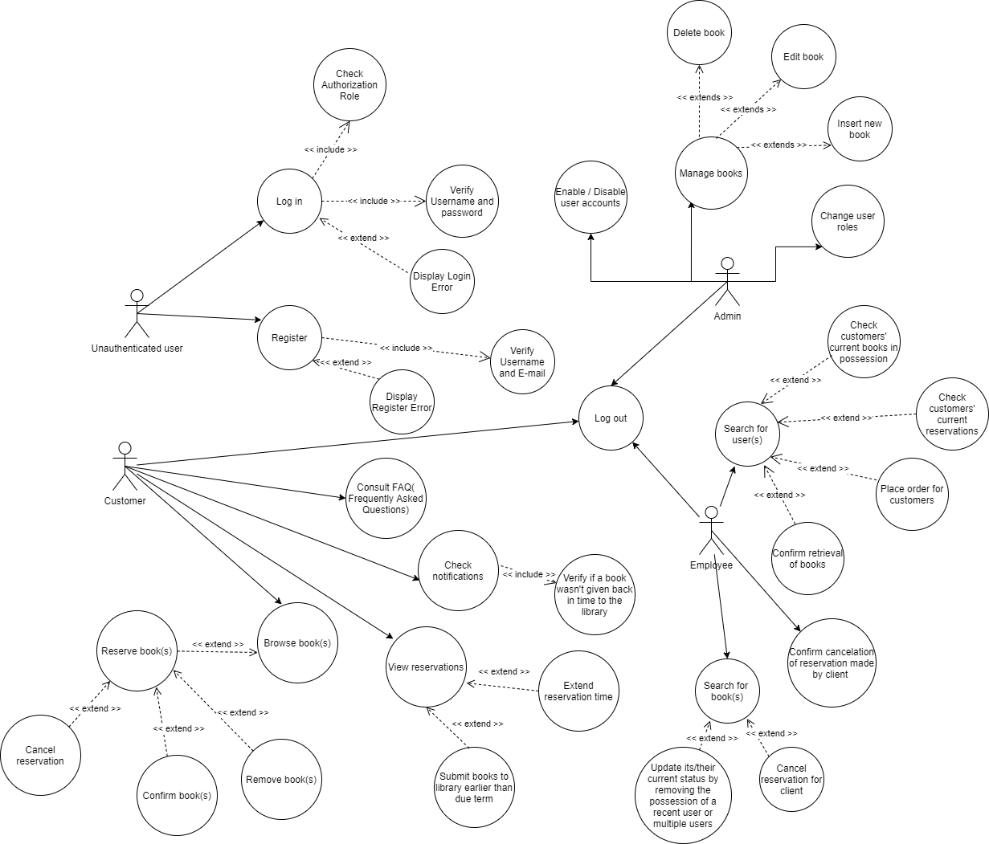

Specifications on the Use Case Diagram

- The human like drawings represent actors, which are meant to represent the types of users (Customer, Employee, Admin, Unsigned User) for this application.
- The circles which have an arrow pointed to represent the main functionalities (such as Log in, Register, Consult FAQ, etc.) of the application.

- The circles which have a dot-pointed arrow pointed to with << extend >> mark represent the extended functionalities from certain functionalities (e.g.: Extend reservation time can only be performed if the user performs firstly View Reservation functionality).

- The circles which have a dot-pointed arrow pointed to with << include >> mark represent the included server-side functionalities which take place in parallel after performing certain functionalities (e.g.: when a user tries to Log in, authentication and authorization processes begin check if the Log in credentials are valid. If they are validated, the user will be redirected to the home page assigned based on user’s role. If the credentials are invalid, an error display message will be shown.).

